Fostering inclusive growth, health and equity by mainstreaming water quality in River Basin Management in the Brantas River Basin, Indonesia
Project duration Start date: 1-5-2017
Final date: 30-9-2022

Project location(s) | Indonesia, Brantas River Basin (WP 2 and 4 focuses on the entire river basin, while WP3 focuses on the river section downstream of Cheiljadang)
FDW theme | ☒ Improved river basin management and safe deltas
Secondary theme | ☒ Sustainable access to clean drinking water and sanitation (including waste)
Project purpose | The project strengthens focus on water quality within Indonesian river basin management. A public-private capacity-building program mobilizes stakeholders to develop integrated water resources management, supported by  - innovative community conservation initiatives,  - strong cooperation among CSOs, local government and private entities,  - Dutch expertise on good governance, hydrology and water quality.  The project promotes inclusive growth, public health, and socio-economic and gender equity.
Project key outcomes and outputs | Outputs  - Inter-ministerial and central-regional governmental cooperation on water governance and management based upon decision support systems which integrate water quantity and quality.  - Multi-stakeholder negotiation platform(s) that enable local groups (poorer communities, women groups) to negotiate their rights and interests are initiated, strengthened and/or replicated in 2-3 sub basins. This includes capacity building and technical assistance to empower these groups.  - Water quality management plan in Brantas river basin, based on systematized guidelines for mainstreaming water quality in IWRM in river basins in Indonesia (or strategy/policy on this theme) and a automated Water Quality Monitoring System– including (i) self-operating underwater drones, (ii) passive sampling techniques in combination with standard grab sampling, participatory monitoring apps and data loggers – which allows timely and juridical binding monitoring of polluters and prevention of unwanted leakages.  - A successful pilot ready to be up-scaled to (inter-) national government policy regarding mainstreaming water quality in IWRM.  - A Clean Industry Hub which facilitate B2B (Business to Business) groups which facilitate industries: (i) in the formulation and adoption of CSR policies and industrial waste water treatment facilities/technology, based up Environment Impact Analysis studies and (ii) tailor-made coaching packages which assist the industry to sustainably transform their waste management.  Outcomes:  - Brantas/Surabaya rivers become a sustainable source for public water supply of Surabaya (with reduced costs as well).  - A concrete example how to regulate integration of water quality in Indonesia’s water resources management.  - Reduced public expenditure on health due to the less (severe) water borne/related diseases.  - More income secure households due to increased health (ability to work) and higher generated income from fisheries (in the river and delta’s) and small scale agriculture.  - Improved participation of women community leaders and an increase in women delegations with access to multi-stakeholder coordinating platforms for river basin management.  - Resilient river basins that fulfil their functions regarding biodiversity and (clean) water availability.

Summary
Over the past 20 years, water quality in Indonesia has deteriorated due to an increase of water pollution. Research and analysis is needed to identify pollution sources and assess contamination in Indonesian water resources. Water quality management is not yet sufficiently integrated in river basin management in Indonesia, which mainly focuses on water quantity. Women are comparatively highly impacted by failing water resources management, but their involvement in decision making processes is limited. Water quality deterioration continue to increases socio-economic inequality, as it are the most poor communities who live on, and along the river. The uneven water quality related disease burden in Brantas River Basin widens the socio-economic gap between societal groups. In the Brantas region, cooperation and intention between stakeholders to tackle these issues is growing, but is fragile as well due to the overlap of institutional mandates , the poor status of water quality monitoring networks and the industries not easily committing themselves to process water before disposal. The
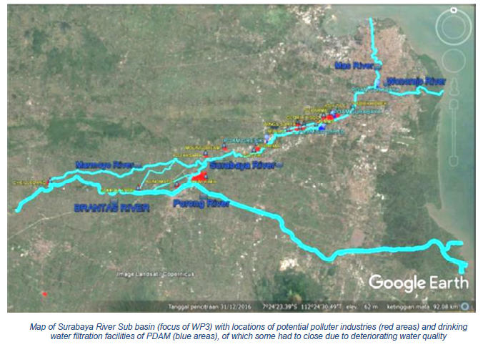
existing group of Indonesian change makers will be supported by this project. Three Indonesian and three Dutch consortium partners will support negotiation platforms in order to deal with solve institutional challenges, to increase capacity to monitor water quality, build an enabling environment to allow sustainable industrial change, and develop an enabling environment in support of community
concerns and civil society initiatives. The project builds on integrated water quality monitoring and modelling within a framework of social learning. The strong consortium will be able to build links with civil society groups (including women, farmer and fisher unions) in close cooperation with local, regional and national Indonesian government institutions to clean the Brantas river and secure income
and health for East Java’s population, in particular the most vulnerable groups.
Partnership
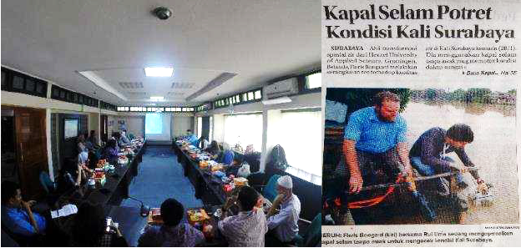
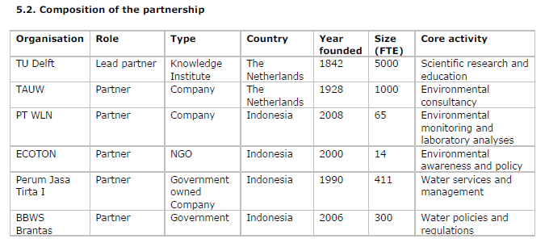
Partner TAUW: (former Technical Advise authority Union of Water authorities founded in 1928) has
positioned itself among the market leaders in The Netherlands and Western Europe on the themes of
‘Environmental Management’, ‘CSR’, and ‘Water Management and Rural Development’. TAUW is extending its market to Asia, having projects on river rehabilitation in the Philippines, Taiwan and India. TAUW is interested to explore the Indonesian market as well. Its long-standing relation with Delft University and INDYMO (asked by ECOTON for the baseline study) provides a credible and robust opportunity.

Work packages
The project runs for five years. The activities are organized into six Work Packages, which are described in more detail in the respective tables. Summarized, the WP’s are these (the interconnectedness of these work packages is represented in the figure):
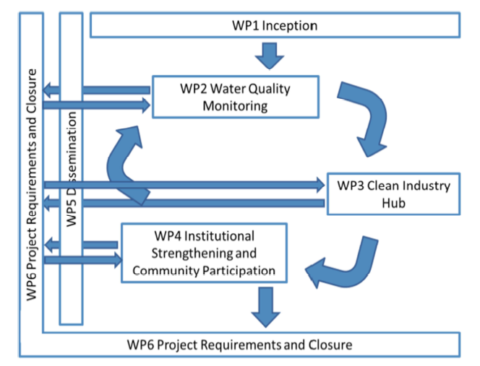
- WP 1. Inception, as defined by RVO. Lead by TU Delft.
- WP 2.Water Quality Monitoring: Transforming scientific information into policy relevant information, establishing an innovative water quality monitoring network, and linking water quality and hydrological data to useful information for social learning issues. Lead by WLN.
- WP 3. Clean Industry Hub: Transforming industrial water use and pollution, changing and creating business models for sustainable innovation within industries. Lead by Jasa Tirta (PJ-1T) and TAUW.
- WP 4. Institutional Strengthening and Community Participation: Strengthening integrated water management and stakeholder involvement, related to water quality and water use. Establishing a Brantas Water Quality Platform. Lead by ECOTON.
- WP 5. Dissemination: Linking the project to the wider policy and academic communities. Lead by TU Delft.
- WP 6. Project Requirements and Closure, as defined by RVO. Project management. Lead by TU Delft.

Planning and milestones
